Software Architecture Documentation template
Overview
This document provides an overview of the architecture of [Project Name], a web application developed to [describe the purpose or goal of the project]. It outlines the technical specifications, identifies key problems addressed, and presents the solutions implemented.
Technical Specifications
Technologies Used
- Frontend:
- Framework: Bootstrap
- Languages: HTML CSS JavaScript
- Libraries: None
- Backend:
- Framework: Express JS
- Database: None
- Languages: JavaScript (Node.js)
- Deployment:
- Hosting: vercel
Problem
[Describe the key problems or challenges that the project aims to address. This may include technical limitations, user pain points, scalability concerns, etc.]
Solution
Architecture Overview
[Provide a high-level overview of the architecture, including components, interactions, and data flow (UML Diagram)]
Frontend
[Describe the frontend architecture, including components structure, state management, routing, and any third-party integrations.]

Deployment
[Detail the deployment architecture, including server setup, scalability considerations, continuous integration/deployment pipelines, and monitoring strategies.]

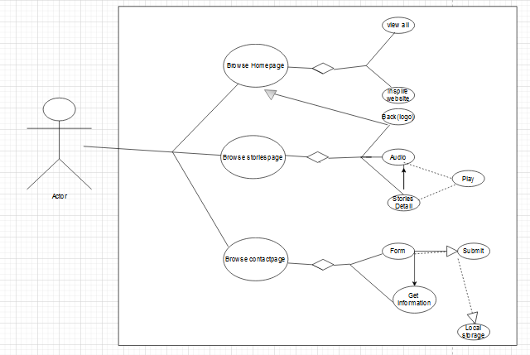

Conclusion
[Summarize the architecture, highlighting key decisions, trade-offs, and future considerations.]

